What is Socket programming?

Socket is an endpoint of a 2-way communication between programs running on the network.

** How socket works?

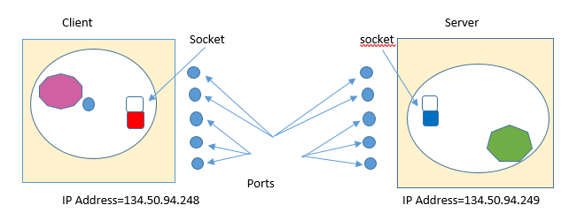

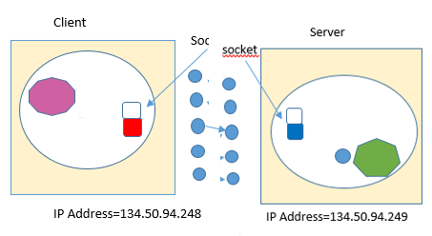

Why socket required?

* When we desire a communication between two applications possibly running on different machines,we need sockets.
* To build any network Application

i.e-Web browsers,FTP etc….

What is socket address?

IP address(192.68.21.3) – It is used for host to host connection.

Port number(80) – it is used for the process to process communication in the network.

** They are created socket address(192.68.21.3:80)

What is Socket programming?

Socket programming is a way of connecting two nodes on a network to communicate with each other.

Which functions are used for socket programming?

The main functions in <sys/socket.h>are:

* socket()
* bind()
* listen()
* connect()
* accept()
* send()/recv()/read()/write()/sendto()/recvfrom()
* close()

Categorized function between Server and client.

Client Server

Client function Server function

Socket

Connect() bind()

Listen()

Accept()

Send()/recv()/sendto()/recvfrom()

Close()

System function for socket programming

user-1 user-2

Socket() 1 endpoint for communication 2

Bind() 1 2

Connect() 1 2

Listen() 1 2

Accept() 1 2

Send/recv() 1 exchange the data 2

Close() 1 end of communication 2

Socket():- socket()- A connection Endpoint

Purpose:- It creates socket

|  |  |
| --- | --- |
| Family | description |
| AF_INET | IPV4 |
| AF_INET6 | IPV6 |

Syntax:- int socket(int family,int type,int protocol)

|  |  |
| --- | --- |
| Type | Description |
| SOCK_STREAM | Stream Socket |
| SOCK_DGRAM | Datagram Socket |

|  |  |
| --- | --- |
| Type | Description |
| IPPROTO_TCP | TCP Protocol |
| IPPROTO_UDP | UDP Protocol |

Example:-

int socket(AF_INET,SOCK_STREAM,0)

Bind():-

Bind()- Attaching to an IP and Port.

Purpose:- Attach itself to a specific port and IP address.

Syntax:-

int bind(int sockfd,struct sockaddr *serv_addr,int addrlen)

sockfd=socket descriptor returned by socket()

serv_addr=It contains server IP address and port.

Addrlen= length of the address in bytes.

Example:-

Struct sockaddr_in serv_addr;

Serv_addr.sin_family=AF_INET;

Connect():-

Connect()- connect to a server port.

Purpose:-Connect to a server port.

Syntax: int connect(int sockfd,struct sockaddr *serv_addr,int addrlen)

Listen():-

Listen():- Wait for a connection

Purpose:- The server process calls listen to tell the kernel to initialize a wait queue of connections for this socket.

Syntax: int listen(int sockfd,int backlog)

sockfd=socket descriptor returned by socket()

backlog=Maximum length of the pending connections queue.

Example:- int listen(sockfd,10);

It means this will allow a maximum of 10 connections to be in pending state.

Accept():-

Accept():- A new connection.

Purpose:- accept new connections from new clients

Syntax: int accept(int sockfd,struct sockaddr *cli_addr,int addrlen)

Sockfd=socket descriptor returned by socket()

Cli_addr=will hold the new client’s information when accept returns.

Addrlen=size of client address

How many types of socket?

socket

stream socket datagram socket